**EX 3 – ARTIFICIAL INTELLIGENCE**

1. **NON PERSONALIZED**

The data we need for non-personalized:

Books and ratings. In the file books.csv: books_id and title. And in the file ratings.csv: books_id and rating.

(It recommends according to the rating and all users have the same recommendations.

1. **Get simply recommendation:**

To get the k best recommedations,

- We first, calculated the number of voters for each book : v

- We calculated the average rating for each book : R

- We fixed the minimum number of voters, like in the Tirgul : (quantile(90)) : m

- We got the average rating of all books : C

- Finally, we calculate the weighted average rating :

WR = $\frac{v}{v+m}*R+\frac{m}{v+m}*C$

-The function returns the k books getting the highest value of WR.

The 10 recommended books are:

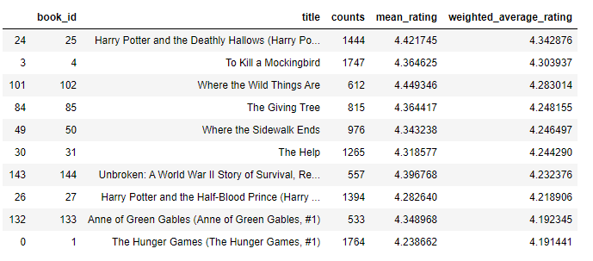

We used dataframes and the pandas package to get all of those results.